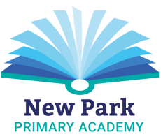
New Park Christmas Celebration 2018!

14th November 2018
Dear Parents/Carers,

On Wednesday 19th December we will be holding a Christmas Celebration Day for all to enjoy. The fun-filled day will consist of a variety of events and activities throughout the day and before and after school. Please return the slip below, with the appropriate payment (in cash please) by 30th November at the very latest.

Each event has a charge and children (and parents for the breakfast and Christmas lunch) can attend/take part in as many as they wish.
…………………………………………………………………………………………………

Name of Child: ______________________________ Class:_________________

Name of Child: ______________________________ Class:_________________

Name of Child: ______________________________ Class:_________________

Name of Child: ______________________________ Class:_________________

Activity | Cost | Number of children/adults attending | Total Cost
Family Christmas Breakfast  7.45am – 8.45am (all family members welcome) | 50p per person
Christmas Jumper/Outfit  Wear a Christmas jumper/outfit to school | 50p per child
Turkey Christmas lunch  Enjoy a delicious Christmas lunch, with crackers and party poppers!  Please indicate the quantity of vegetarian meals required below (quorn chicken):  _______ | Free for Reception and KS1  Free for Free School Meal children  £2.50 for children £3.00 for adults
Visit Santa’s Grotto – EYFS and KS1 only  A present for all who visit! | £2.00 per child
Christmas Party  with games and treats | £1.00
Christmas Movie  3.15pm – 5.15pm, with a hotdog, sweets and a juice drink | £2.50
Total Cost |  |  | £

Signed:………………………………………………………..

