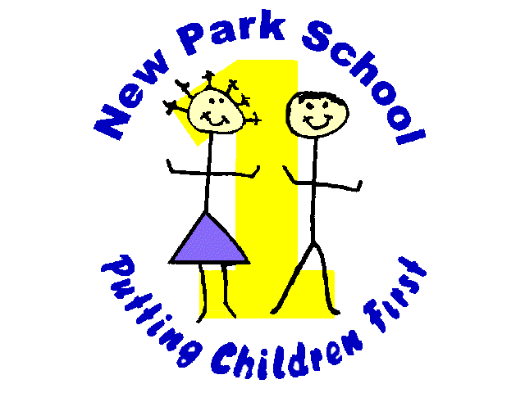

NORTHERN STAR ACADEMIES TRUST
New Park Primary Academy
Skipton Road Harrogate HG1 3HF
Telephone 01423/503011 and 531397 Fax: 529094

E-mail: admin@newpark.n-yorks.sch.uk
Headteacher: Mr. A. Tomlinson

Date: 25.01.2016

Dear Parents,

Welcome to our new home in the lower building, we out grew the last room and now we have a much bigger space for the children. We are pleased and proud at how the breakfast and afterschool club has grown over the last year. As with everything we have had to review our policies and we have listed them below for you.

- The hours are as follows for breakfast club and afterschool club:

Breakfast Club – 7.45am – 8.45 am
After School Club 3.10pm – 5.15pm

- If you drop your child off in the morning before school starts you will incur the breakfast club hourly charge, as a member of staff will bring them to us to look after.

- If you are late to collect your child or children, you will incur a late charge of £15 and then £5 for every 5 minutes you are late. We will always look to help parents as we understand that problems arise, but reoccurring lateness will be charged.

- Invoices will be sent out on a monthly basis, (we thank you for your patience in the December 2015 invoice changing to the academy held things up) at the end of every month. We ask that ALL invoices be paid online, the information will be on the invoice.

- We would also ask that invoices please be paid within 7 days. Any outstanding invoices may result in no breakfast club or after school care until remaining balances have been cleared.

- All children MUST be booked in to After School Club, and we need to know what time they will be collected to ensure we have enough tea snack for all the children, it also stops confusion at home time with us and the teachers.

If you have any questions please don’t hesitate to ask a member of staff in the club

Many Thanks
BASC Team

