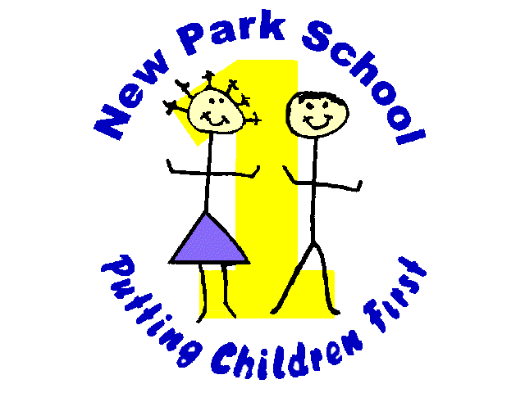
New Park Primary Academy
Skipton Road, Harrogate North Yorkshire HG1 3HF
01423 503011
admin@newpark.n-yorks.sch.uk

Head Teacher: Mr R Mold

New Park Community Learning Farm
Project Consultation – New Park Primary Academy

New Park is presently looking into applying for funding from the lottery to develop a community learning farm on an area of land owned by the school. The school would like to use this space to provide outdoor learning experiences about animals, the natural world and growing food. The aim is for the farm to be open to both the school and the local community and to be a focal point for the area. We are keen to work alongside local allotment groups and other interested parties and would like all who are interested to get involved in helping us design, create and manage the facility. We are particularly keen to hear from people and organisations who would like to help us manage this community resource, in particular, outside of school time.

We hope to engage local people in our community in this project. We are looking for people that have experience and skills they feel they can bring to the project, young people who wish to gain skills and experience, the older generation and those that might feel isolated. We want to ask our local community members about their views on this project and would be grateful if you, as a community member/organisation, would answer the following questions relating to the project.

1 | What part of the community are you from? (please tick)  Parent of under 5  Parent of school aged children  Retiree  Person without children (not retired)  Other (please state)…………………………………………….
2 | Do you feel there is a need for a project like this in our locality? (please tick)  Yes No  If you ticked yes please explain briefly why you feel there is a need?  ………………………………………………………………………………………………………………  ………………………………………………………………………………………………………………  ………………………………………………………………………………………………………………
3 | How do you feel our community would benefit?  Our community would have better opportunities  Our community would learn about respecting our natural environment  Children would learn about nature, farming and food  Our community would develop more confidence and new skills  Our community would be healthier/fitter  Our community would become stronger and more connected  Other  ……………………………………………………………………………………………………………..

New Park Primary Academy
Skipton Road, Harrogate North Yorkshire HG1 3HF
01423 503011
admin@newpark.n-yorks.sch.uk

Head Teacher: Mr R Mold

New Park Community Learning Farm
Project Consultation – New Park Academy

4 | Would you be happy to get involved in creating our community farm?  Yes No  If yes, how would you be willing to help us?  Creation of the farm  Support in running the farm (outside of school time)  Support in providing educational sessions with the children  Smallholding knowledge and advice
5 | How do you feel you would benefit from this project?  It won’t benefit me  It would keep me fit/help me get fitter  It would get me out and help me socialise  I would learn new skills/knowledge  It would help me to develop more confidence -  I could share my own knowledge and skills
6 | Would you support our project?  Yes No  Explain what you feel you could bring to the project?  ……………………………………………………………………………………………….
7 | Tell us in a few words what you would like to see in the farm.  ……………………………………………………………………………………………….  ……………………………………………………………………………………………….  ……………………………………………………………………………………………….

Name: ……………………………………………………. (optional)

Contact details: …………………………………………………………………………. (optional)

Thank you for your help.

