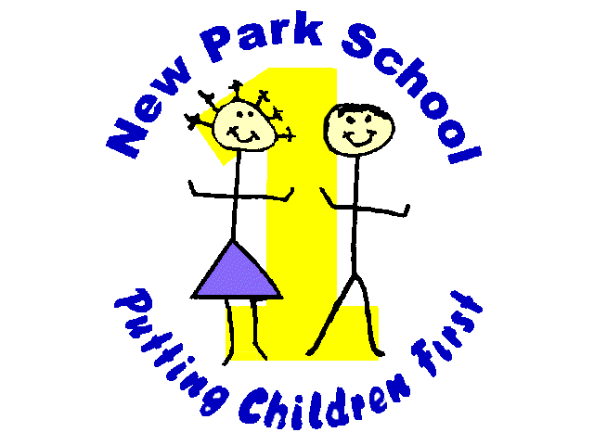

NORTHERN STAR ACADEMIES TRUST
New Park Primary Academy
Skipton Road Harrogate HG1 3HF
Telephone 01423 503 011
E-mail: admin@newpark.n-yorks.sch.uk
Headteacher: Mr. R Mold

Dear Parents and carers,

Welcome back to the Summer term! We’re excited to be able to offer a range of new lunchtime and after-school clubs this term. Many of these are run by school staff and are available free of charge. We’re also thrilled to be working with the Yorkshire Bushcraft Company and FiiT Like a Girl to offer new experiences for our children.

Bushcraft club will involve lighting fires, building shelters and learning about the natural world around us.
FiiT Like a Girl is a specially structured fitness class for KS2 girls that helps to raise confidence and self-esteem. Both of these are local companies, keen to work with us and support local children.

If your child wishes to attend one or more clubs, please fill in and return the slip below. If your child attends multisports or FiiT Like a Girl, payments should be made directly to the instructor.

All clubs run for 8 weeks from Monday 30th April and finish at 4:30pm.

 | Monday | Tuesday | Wednesday | Thursday | Friday
Lunchtime | Reading club (KS2) | Times Table Rock Stars | Lego club | Colouring club (Y1-3) | Circle time games  (Reception – Y2)
After-School | Gardening club  Y6 revision  Reading club (Reception – Y2) | FiiT like a girl (KS2 girls only)  £25 for 8 weeks  KS1 Cookery club  £4 for 8 weeks | Rounders and Cricket (Fully booked) | Bushcraft (KS2 only)  £25 for 8 weeks | Multisports  £3 per session

Please return these slips by Thursday 26th April, giving clubs in order of preference. We will try to give all children who wish to attend one of their first choices but this may not always be possible.

Mr Mold
…………………………………………………………………………………………………………………………………………………………………………………

Name of child: _____________________________

Club choice(s)
1st choice _________________________________

2nd choice _________________________________

3rd choice__________________________________

