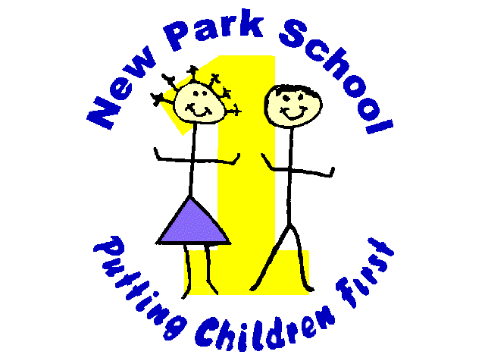

NORTHERN STAR ACADEMIES TRUST
New Park Primary Academy
Skipton Road Harrogate HG1 3HF
Telephone 01423/503011

E-mail: admin@newpark.n-yorks.sch.uk
Headteacher: Mr. R Mold
13th June 2018

Dear Parents/Carers,

We are very excited about the events taking place during the summer term. Please find below a list of dates for your diary, we hope you will be able to join us.

Date | Event | Note
Thursday 5th July | Sports Day | Children can wear their PE kit to school. Team games in the playground from 9.30am. Family picnic lunch at 12pm followed by competitive races on the field. Children who usually have school meals and those eligible for free school meals will be provided with a packed lunch.
Thursday 5th July | Summer Fayre | From 3pm in the school playground – stalls, games, exhibits, raffle, bouncy castle, BBQ and much more!
Saturday 7th July | Beach Trip | Family trip to Saltburn-by-the-Sea (see attached letter).
Tuesday 10th July | New Park History Day | Join us at school between 2 and 4pm where the children will take you on a journey through time and share their learning on the history of New Park school and surrounding area. Visit the Heritage Centre and enjoy refreshments served by Y6. Please invite friends and family from the community and share the event on our Facebook page.
Wednesday 11th July | Transition Day/Open Morning | Join us between 9 and 10am to meet your child’s new teacher and join in some team building activities!
Wednesday 18th July | Y6 School Production | Parents and family are invited to watch ‘Superstan’ at 6pm. Tickets can be purchased from the office for 50p.
Friday 20th July | End of term / Leaver’s assembly | All parents welcome.

Finally, we also have two vacancies for Parent Governors for our newly assembled Local Governing Body. This is a fantastic opportunity to represent the views of parents and contribute to the vision and development of the school. Please contact the office if you are interested by 22nd June 2018.

Mr Mold

