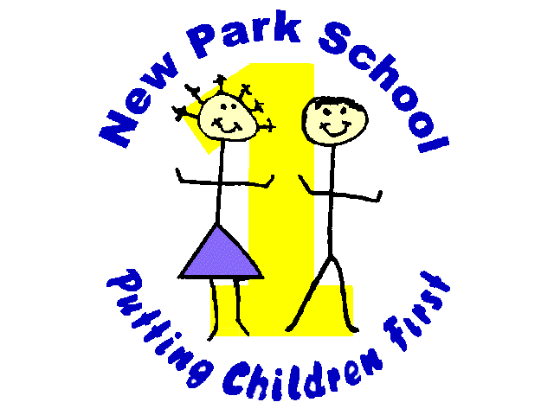

NORTHERN STAR ACADEMIES TRUST
New Park Primary Academy
Skipton Road Harrogate HG1 3HF
Telephone 01423 503011

E-mail: admin@newpark.n-yorks.sch.uk
Headteacher: Mr R Mold

4th June 2018
Dear Parents and Carers
PTFA Summer Movie Night
The PTFA will be holding a Summer Movie Night on Thursday 14th June 2018.

The event will run from 3.15pm to 5.15pm and is open to children from Nursery to Year 6.

Children should be collected from the main reception at 5.15pm.

The cost of the movie will be £2.50 per child – this includes a drink and a hotdog.

All proceeds raised will go into the school PTFA fund to raise money for the Summer Fayre.

Please return the slip below by Monday 11th June 2018.

----------------------------------------------------------------------------------------------------------------------------------------------
I give permission for ___________________________________ to attend movie night on 14th June 2018 and watch the film ticked below. I enclose £2.50 cash.
Film choices:
The Greatest Showman

Jungle Book

Signed: ______________________________________ Date: _________________________

