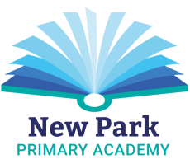
New Park Primary Academy Before and After School Club
Terms and Conditions

The Welcome Pack and Registration Form make up New Park Primary Academy’s Terms and Conditions. By signing below, you acknowledge that you have read, understood and agree to abide by them.

To use the club you must:

- Fully complete, sign and return a Registration Form.
- Pay in advance. Places at club are only confirmed on ParentPay once full payment has been received.
- Be responsible for booking and/or cancelling your child’s place via ParentPay.
- Pay a charge of £5 per child per 15 minutes (or part of) if your child is collected after 5.30pm.

Your name (print)…………………………………………………………………………….. Date………………………………………

Your signature……………………………………………………………………………

